Five Simple Sample Letters to Oppose Proposed Microcell Installations where you Live
1. Potential 4G/5G Wireless Telecommunications Facilities
Dear Mayor and Council of _______,
We have recently become aware of the possible arrival of 4G and 5G wireless networks in our neighborhood and we are very concerned about the serious adverse health and environmental impacts caused by the microwave radiation emitted from these 4G and 5G microcells. Wired fiber-to-the-premises is a much safer, faster option. We urge you to please prevent the installment of these dangerous antennae in______________.
Yours sincerely,
2. Dear Mayor and Council of _______,
I am deeply concerned about 5G and Radiofrequency Radiation (RFR). Here is a recent article you may find interesting and informative. It is about a 10 minute read.
https://childrenshealthdefense.org/news/the-dangers-of-5g-to-childrens-health/
Bottom line
5G small cell transceivers are a huge danger to our health and especially the health of our children and grandchildren.
Cheers,
---------------------------------------
PS - Extra info
Note how the 5G antenna will transmit a narrow beam of RFR directly to the smart phone.
If the smart phone is streaming video then both the phone and the viewer will be bathed in a high dose of RFR.
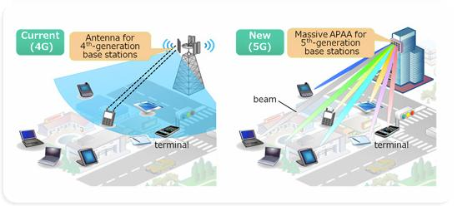

3. Dear Mayor and Council of _______,
Regarding placement of SG Mini Cell Towers in_________, we are very concerned about the serious adverse health and environmental impacts caused by the microwave radiation emitted from 4G and SG Microcell Towers. We do not want high frequency energy waves pumped into our neighborhoods. The long-term impact to the health of our residents is unknown. SG is not necessary. Wired networks, both optical fiber and copper, are a much better option than the potentially harmful SG wireless networks. Fiber optic cable is faster, more secure, more reliable, more energy efficient, more cost effective, healthier and safer than wireless networks. Please prevent the installment of these dangerous antennae in______________.
Thank you!

4. Dear Mayor and Council of _______,
We are very concerned about the serious adverse health and environmental impacts caused by the microwave radiation emitted from 4G and 5G Small Cell Towers. Please put this topic on your Agenda and prevent the installation of these dangerous Close Proximity Microwave Radiation Antennae in___________________. Please promote community-owned fiber-to-the- premises and help us maintain local control in the face of corporate pressure.
Warmly,

5. Dear Mayor and Council of _______,
My family is opposed to the installation of Microcell Towers in and around___________. One of the reasons we chose to live ___________is that it is a very environmentally aware and health-conscious community. There could be serious adverse health and environmental impacts caused by the microwave radiation emitted from 4G and 5G Small Cell Towers. We DO NOT want to be the "testing ground" or the "lab rats" for this technological advancement. We have seen no concrete evidence that these radiation-emitting towers are safe, only evidence to the contrary. Please promote wired fiber-to-the-premises and prevent the installment of these dangerous antennae in____________. Thank you!
Very truly yours,

