There Goes the Neighbourhood!
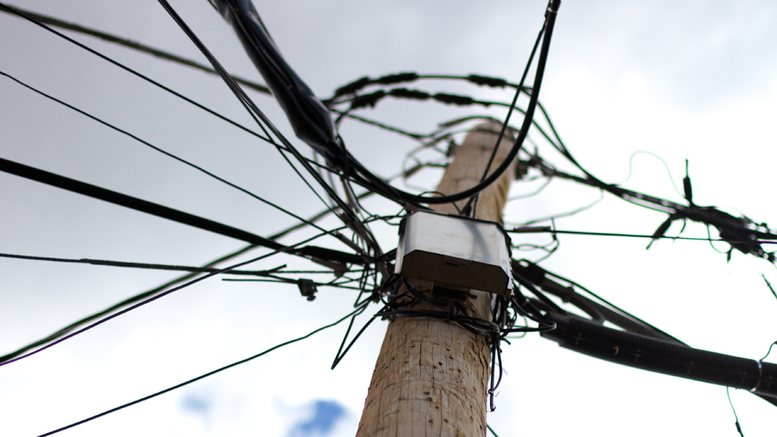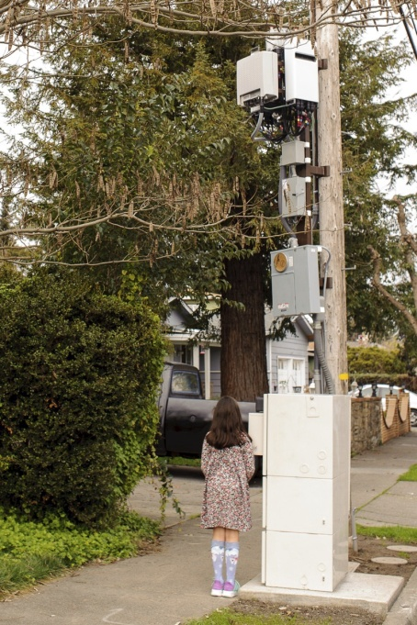-

Across the nation, telecoms are laying the groundwork for 5G. Do you want a small cell antenna installed right by your home, or a slew of 5G satellites polluting our night skies?
The Canadian government is allowing telecoms to place small cell transmitters on utility poles, lampposts, existing cell towers and more without our input or consent. Telesat Canada plans to launch 300+ 5G-enabled satellites in our skies.
Like all wireless and cellular technology, 5G emits microwave radiation. Experts warn 5G will negatively affect data privacy, national security, global climate change, weather forecasting, and the health of humans, plants, and wildlife.
We may want fast internet but we don’t need 5G. Wired fiber-to-the-premises will always be faster, safer, greener, and cheaper than wireless 5G. Wired fiber can fulfill most of the “Smart City” functions 5G promises, without the problems.
Please join us as we gather to build a healthy world for generations to come.
When: ____________________________________________________________
Where: ____________________________________________________________ For more information, call _____________________at _____________________

